SUSSEX COUNTY BADMINTON ASSOCIATION ANNUAL REPORT 2025/26

AGM for end of season 2025/2026 10th August 2026 Zoom call – details circulated to active Sussex Badminton England Members.

Chairman Report: Mark Russ writes

Competitions and Tournaments
As reported at last year's AGM, Malcolm Jellows took on the task of running Badminton England sanctioned events in Sussex. This was a role that was very much needed, giving Sussex players the opportunity to compete against players from all over the country without having to travel long distances every weekend.
Malcolm put on three Tier 4 events, a Senior Bronze and a Senior Silver this year, and for someone who runs a lot of tournaments, that is a huge amount of work and a real commitment, for which we are grateful. His efforts have been rewarded with all the events proving extremely popular: over 100 players entered the Tier 4 events and more than 80 entered the Silver event. It was great to see a significant number of successes for Sussex players across all the tournaments.
In addition to the Badminton England events, Sam Huggett and Malcolm continue to run the 3/4 Series, aimed at attracting club players from all areas of Sussex. Sam would very much like to see the various Districts hosting these events get more involved, as this should help increase entries — and there is an incentive, since Districts receive a share of the profits. If you would like to help run these events, please get in touch with Sam or myself.

Senior County Teams

Having lots of opportunities to gain match-play experience should help all Sussex Senior teams going
forward. This season was a difficult one for the Senior County teams: our 1st and 3rd teams were relegated, but the 2nd team had a great campaign, finishing runners-up in Division 2. As more of our Juniors transition into the Senior teams, we hope their youthfulness will help the county climb back up the leagues.

Masters Badminton
Masters badminton is thriving, with new members asking to be added frequently. See the full report for details of their update.

Junior Badminton
Junior numbers continue to increase, and this year will see teams competing in all four age groups of the Shires Badminton League once again. See Neil Warwick's report for more details.

Player Success: Zach Russ
A former Sussex player, Zach Russ, has had his best senior season so far: winning a doubles bronze medal at the European Championships, and winning both the Azerbaijan International and the Irish Open doubles events. Zach has now been selected for the World Championships in India at the end of August.

Facilities and Venues
As reported at last year's AGM, finding badminton courts is becoming increasingly difficult, and the continued growth in the popularity of pickleball has not made this any easier this season — it is likely to remain the case going forward. To help alleviate this problem, Malcolm Jellows, David King and I have been looking for potential sites to establish a Sussex badminton centre. Malcolm has identified a school that wants to partner with us as and when they develop their new sports hall; however, a significant capital sum would need to be put forward to help with the overall build cost.

Following discussions with Badminton England, Sussex has been highlighted as an area that needs help with funding and developing venues. A meeting subsequently took place with Sporting Assets, a company Badminton England is partnering with to help counties and clubs look at sites and funding opportunities. To be clear, this is not ‘free money’ — it would be a loan, repaid on favourable terms, but certainly not a donation.

We will continue to look at options and report back in due course.

Badminton England Update
There have been personnel changes at Badminton England recently, and we welcome Luke Hornsley as our new Regional Manager for the South East.

As most of you are aware, the scoring system has once again been changed. Horsham Badminton Club
raised a specific question on this, and the short answer is that local leagues and independently run
competitions will retain autonomy; any competition coming under the auspices of Badminton England will, over time, be required to adopt the 3 x 15 format. My own view is that if you have players entering Badminton England tournaments, the more practice they have playing to 15, the better their chances.

Club Welfare Officer

Julia Alkema has agreed to continue as our County Welfare Officer (CWO).

Thanks, and Committee Changes

Thank you to the committee members for their support in their various roles, and to everyone who has given their time to run clubs and teams this year.
I thanked Phil Huggett last year for the sterling work he had put in over an extremely long time as County Treasurer, and in true Phil spirit, he continued for a further year as we could not find anyone to take over. This year we have found a replacement: Ian Budden, a junior parent, who will run both the Junior and Senior treasury positions for us.

Mark Russ

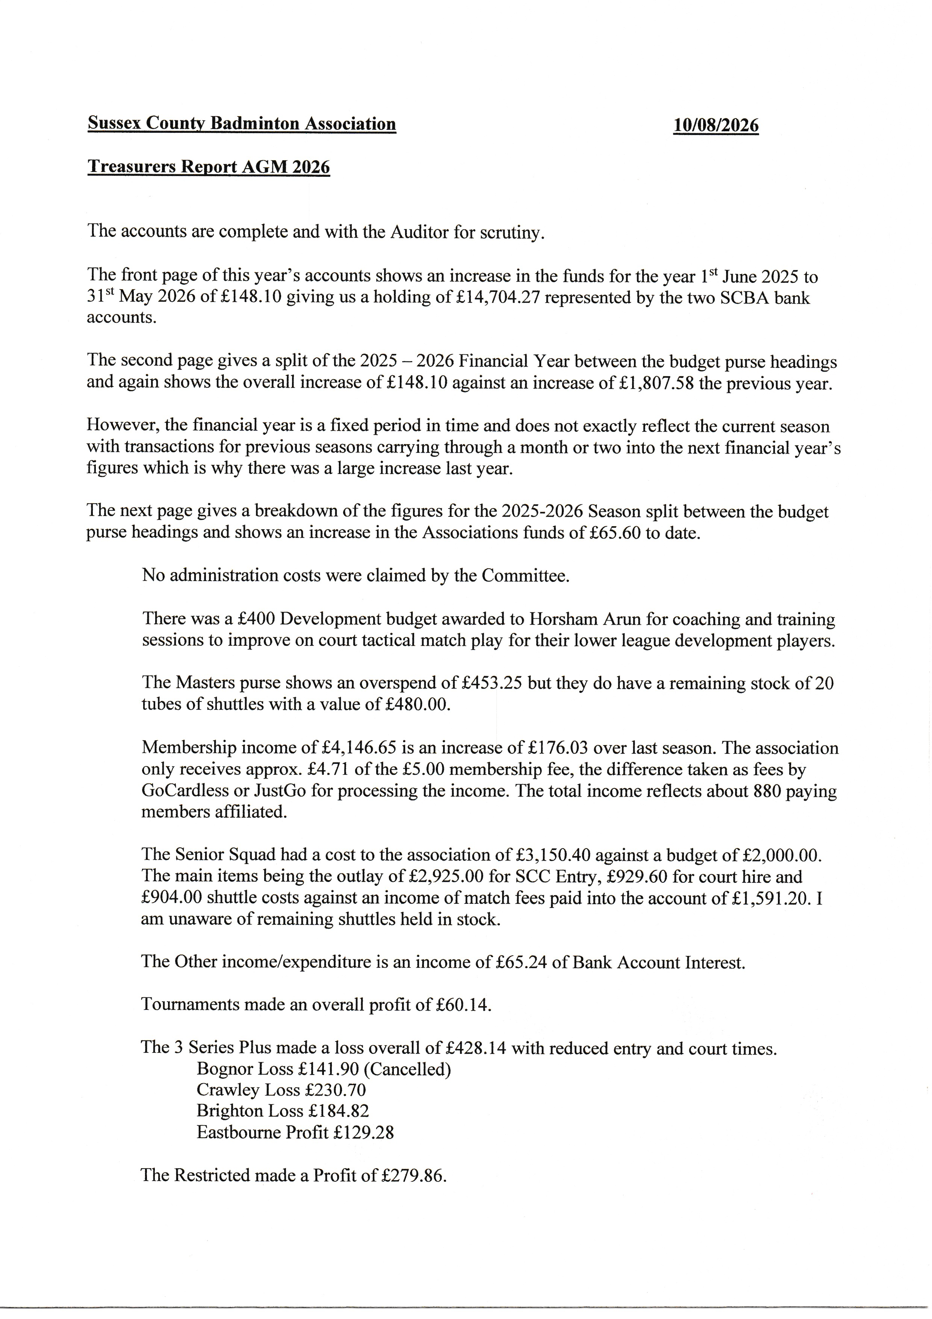
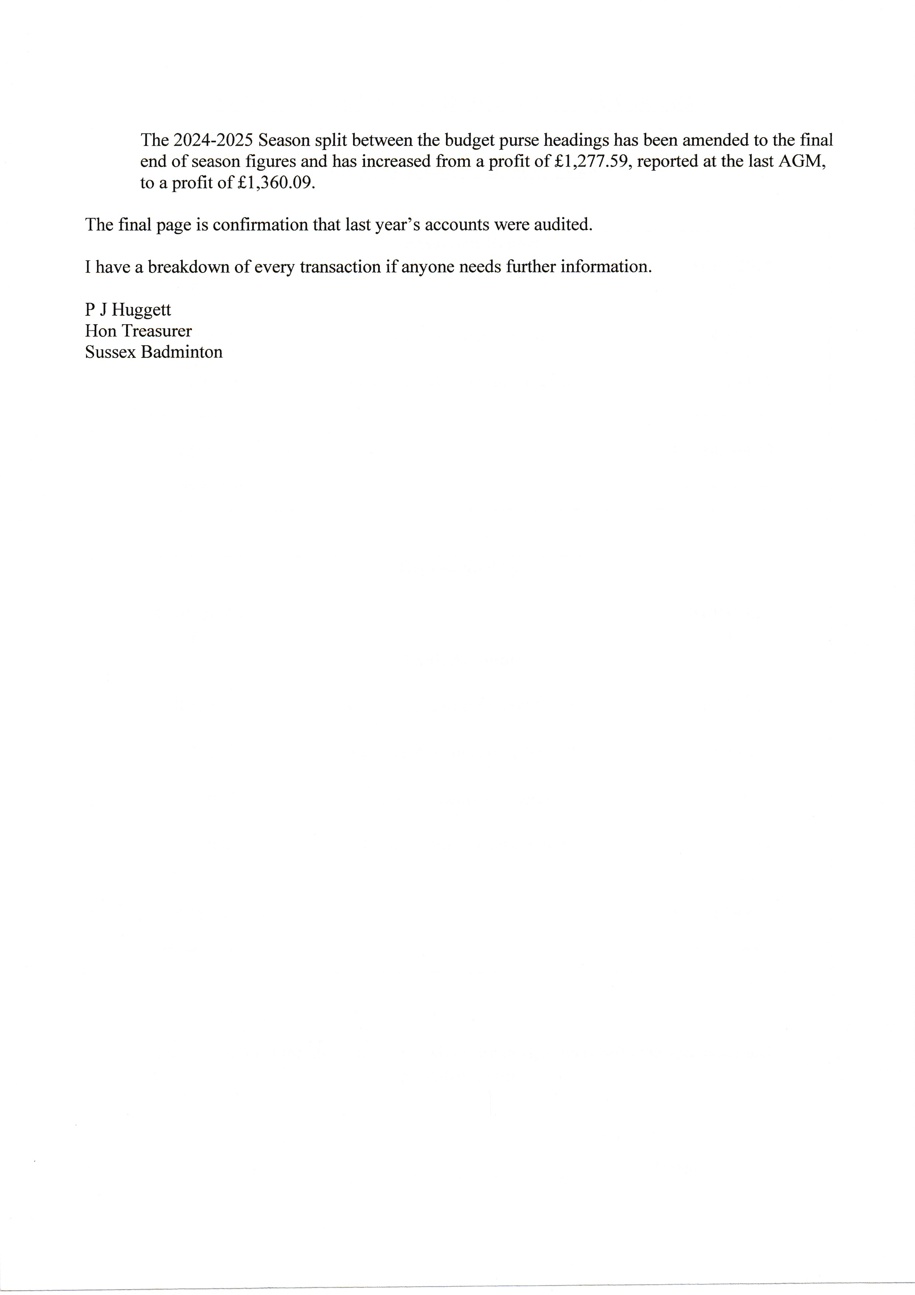

Senior Team Reports

Team Result
1st Team Demoted to Div 1
2nd Team Second in Div 2
3rd Team demoted to Div 4

The first team encountered a series of challenges throughout a demanding season. In a campaign marked by injuries, availability challenges and tough competition, the squad showed resilience but were unable to avoid relegation to Division 1.
Sussex now need to look ahead strengthen and come back more competitive next year. Reinstating county training would be key to this development.
Sussex 2s competed in division 2 South of the county championships.
While we faced challenges in fielding consistent teams throughout the campaign due to player availability, we were able to field a full side each time and this gave a number of players the chance to play for Sussex.
There were several very tight matches including a tight fight on the last weekend to take the number 2 slot with Hampshire running away with the title.
The third team face an uphill battle each weekend notching up 2 wins which sadly wasn’t enough for them to stay up in Div 3.

Thanks to team captains and all players who represented Sussex with pride.

37 players represented the county last season.
Some did cross over and play in two teams.

County Caps
Award Player
Gold (100 caps) Amber Roberts
Bronze (25 caps) Rico Shergill
Kam Ngoulong
Jake Everett Rose
Zak Goodsell
Leon Crayford

Debuts
Player Season
Jonny Avery 2025/2026
Harvey Barrett 2025/2026
Beth Worthington 2025/2026
Fiona Leggat 2025/2026
Helen Milne 2025/2026
Elsie Bryant 2025/2026
Liz Roberts 2025/2026

To be presented at Sussex Restricted 12/13 September 2026

Juniors: Neil Warwick writes:

Following our trials at the end of June 2025, a decision was made not to select a full
U16 squad but to take the few existing team members and place them with U18’s. In
my many years as Junior committee member, this is the first time we have had to do
this, and it was a decision that was not taken lightly.

I am pleased to report that for this coming season we are back up to 4 age squads
and will look to build on this going forward. Once again, we have good squad
numbers in our lower age groups and competition for places is healthy.

For the first time this year we agreed that the Rising Stars tournament would form
the main basis for squad selection in each age group, with players given the option
beforehand as to whether they wanted to be considered or not. This tournament was
held at the end June 2026 at Brighton University where we had extremely good
numbers of entries. Coaches were in attendance throughout the day to see each
player compete.

Juniors not able to attend who still want to be considered have been invited to enter
the Sussex Junior Restricted tournament planned for the first weekend in September
at Sussex University and following this event our final numbers will be known.

The National Schools competition organised by Badminton England continued this
year starting last November, with schools from across Sussex competing at firstly
local, then on to both county and regional rounds. Several new schools from Sussex
competed for the first time this year which is a positive sign. Sadly, no team from
Sussex reached the finals at Milton Keynes in April, but next year’s competition is
already being planned, and information is being issued to all schools

Finally, our end of season awards evening was held at the Sports Pavilion at
Brighton University where over 100 juniors and parents attended. A fantastic time
was had by everyone and a fun evening which will hopefully carry us forward again
for next season.

Badminton England Update
See chairman’s report
3 Series Plus Sam Huggett writes:
The 3 Series Plus made an overall loss of £428.14 this season. Entry was down and court times
had to be reduced.

We trialled the two tier system this year, however we only had enough entries
to actually test this at Eastbourne.

We need to clarify who counts as a county player as there was a lot of questions as to juniors and masters.

Unfortunately, the Bognor district event was cancelled this year due to low entries.

We managed to get enough entries to run the Crawley event although with less than half the
amount of usual entries.

Brighton entry was low too and only a men’s event.

Eastbourne was very well attended this year (higher than average) and I would put this down to it
being our local event. We were able to speak with the local players and convince them to enter
which we can’t do in the other Districts due to locality.

The 3 Series Plus tournaments are intended to be run by each of the 4 districts with my role
overseeing the 4 events and it would be great if we could get back to this. I would like to step
back from running the Bognor District and Crawley District events on the day so it would be
great if we could have a volunteer from each of these Districts to take over. I am happy to do all
admin/set up prior to the tournament but would like a volunteer from the District to run it on the
day. We will help you learn how to do it if needed. Don’t forget, any profits are shared between
the Districts who volunteer!

The overall winners were as follows:
• Mens Doubles – David Jolliffe
• Ladies Doubles – Alexa Hobbs & Beth Worthington
• Mixed Doubles (Mens) – David Jolliffe
• Mixed Doubles (Ladies) – Elizabeth Roberts
No courts have been booked for next season until we know what the plan is moving forwards.

The Masters: Mike Stoneham and Paul Moss write:

We would like to thank all the captains for all their hard work organising the teams
and representing Sussex so well, it is not always an easy job.
The 5 practice sessions were well attended helping the captains to assess new players
and work on pairing for matches.
Sussex entered 9 league teams in the County Championship last season, 40, 45, 50,
55, 60, 65, 70A, 70B and a 75 team.
We used Littlehampton Badminton & Squash Club for most matches others used were
The Bridge, Horsham and The Portslade Sports Centre.
The final team placings were as follows:-
40's finished 4th, 45's finished 1st, 50's finished 7th, 55's finished 4th, 60's finished 4th,
65's finished 4th, 70A finished 2nd, 70B finished 4th, 75's finished 3rd.
Congratulations to the 45's for winning their league. Unfortunately, they lost on count
back to Essex in the play-offs having drawn 6 matches each, well done a great team
effort.
Sussex entered 9 teams in the County Challenge weekend on January 10th/11th 2026,
they finished as follows:-
40's Premier - 6th, 45's Premier - 5th, 50's Div 1b - 4th, 55's Premier - 7th, 60's Div1b -
6th, 65's Div 1b - 7th, 70A Div 1b - 3rd, 70B Div 2b - 4th, 75,s played in 70s league Div
2b - 7th
The Challenge weekend was as always, a successful and enjoyable occasion, being
played at 5 locations around the country on the same weekend.
We would like to thank all the players for supporting their captains, also helping out
by filling in for other teams when needed.

Master’s tournament success (Gold Nationals and All England)

Kent Masters Gold 35’s – MS Will HJ Gold, WS Hannah Seagraves Silver
35’s – Mitsuyo Kondo WD Gold, Hannah Seagraves Silver
35’s – MXD Hannah Seagraves Silver
45’s – Mitsuyo Kondo WS Gold
45’s – Mitsuyo Kondo MxD Bronze
40’s – Phil Troke MD Bronze
55’s – Jane Ashfold WD Gold MxD Silver
60’s – Karen Thomas WD and MxD Bronze
70’s – William Brown MD Silver
070 William Brown MD Bronze
075 Sue Awcock MxD Bronze
Nationals 035 Will HJ Gold MS, Silver MxD, Bronze MD
035 Hannah Seagraves WS Silver, MxD Silver
035 Mitsuyo Kondo WD Gold
035 Elissa Seddon WD Bronze
045 Mitsuyo Kondo WS Silver
045 Phil Troke MD Bronze
055 Jane Ashfold WS Silver, WD Gold, Mxd Silver
055 Sara Foster Mxd Gold
060 Karen Thomas WD Silver
075 Sue Awcock WD Bronze
075 Wendy Arscott WD Silver
Yorkshire Masters Gold 035 Hannah Seagraves WS Bronze, WD Bronze, MxD Gold
035 Will HJ MS Gold, MxD Gold, MD Silver
O45 Mitsuyo Kondo WS Silver
050 Helen Milne WD silver Mxd Silver
055 Jane Ashfold WS Gold, WD Gold MxD Gold
060 Cathy Bargh WS Gold
060 Karen Thomas WD Silver
060 Jane Doswell WD Bronze
All England 035 Will HJ Bronze MS
035 Hannah Seagraves Bronze WS
045 Mitsuyo Kondo Silver WS
050 Helen Milne Bronze WD
055 Jane Ashfold WD Gold, MxD Bronze
060 Karen Thomas WD Bronze

